Survey on the Link between Communication and Public Buildings' Energy Performance Improvement:
Some feedback from the “Display® Questionnaire” sent in December 2007 to every Display® member

Out of all Display® members registered in December 2007, we received 87 responses.

There were 35 respondents who responded to all the questions concerning their local communication campaign. These 35 sets of data were the most important for the aim of our study.

Which countries completed the questionnaire?

The three countries currently the most active in the Display® Campaign are France (FR) with about 120 organisations, Great Britain (GB) with 41 organisations and Switzerland (CH) with 28 organisations. From the graph below, you will be able to see that these three countries have provided more responses than the other countries: 38 questionnaires for France compared to 16 for Great Britain and 12 for Switzerland.
Of the three, Switzerland provided the largest proportion of responses concerning their local communication campaigns with 7 questionnaires out of 12 (i.e. 58% of the questionnaires completed with communication campaign) followed by France with 14 questionnaires out of 38 (i.e. 37%) and Great Britain with only 2 questionnaires out of 16 (i.e. 13%).

Below is the distribution of responses per country.

1. Management, Strategy and Resources
(72 respondents completed this section, meaning that 15 respondents only completed the first section)
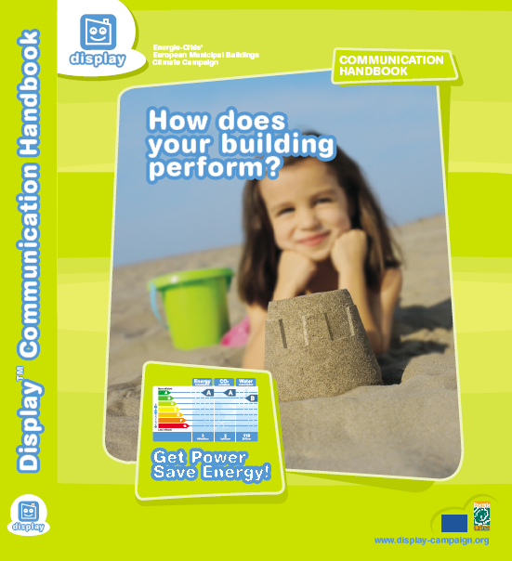
For the majority of respondents, it was easy or very easy to convince the decision makers to join the Display® Campaign (54%) while it was neither easy nor difficult for 33% of them and difficult for 10%.

71% of the respondents who started their communication campaign used the communication handbook and 95% found it useful or useful in part (52% useful and 43% useful in part).

More than half of the respondents who started a communication campaign did not have enough resources to carry it out. The main resource lacking was human capacity (86%), and then finances (59%).

The communication Handbook

2. Buildings and posters
(70 respondents completed this section – 2 respondents stopped after the section ‘Management, Strategy and Resources’)

The total number of buildings the 70 respondents are responsible for is 17,348 buildings equivalent to about 250 buildings per respondent. Out of these 3,242 have been entered in the Display® tool. The proportion of the buildings being entered in the online tool is 19% of the total number of buildings.

However, the important figure in this section is the percentage of buildings entered in the database, that actually have a Display® poster visible. In total 1,746 buildings (54% of the buildings in tool) have a Display® poster, representing about 25 buildings per organisation displaying a poster.

Posters are updated annually for 57% of the buildings.

About a quarter of all the respondents (27%) also said that they were displaying posters for the last 2 years or more (all the years).
(For the 35 respondents who started their communication campaign and completed the questionnaire, the percentage was 39%, showing that the poster display activity is more important once the communication campaign has started).

Where are the posters displayed?

  - Outside the building 7%
  - Inside the entrance 51%
  - In a hallway 28%
  - In a waiting area 6%
  - Other 8%

How many posters are displayed, according to their size?

When analysing the data for all the respondents, the majority of posters were under the common A4 format. However, for the 35 respondents who started their communication campaign and completed the questionnaire, there were more A3 than A4 posters, some A2, A1 and even bigger sizes of posters in ‘Other sizes’, showing that when the campaign has started, the size of display is much bigger.

This is highlighted in the graph below.

3. Communication
(60 respondents completed this section – 10 respondents stopped after the section ‘Buildings and posters’)

Who is the local Display® Campaign targeted at?

Schools are the principal target of the Display® Campaign, followed by the general public and elected people. Below is the distribution of the targets of the Display® communication Campaign.

The users’ reaction towards the Display® Campaign was positive in general: no respondent reported any negative reaction, while 57% said the reaction was positive. The reaction was neutral for about 10% of the respondents and the rest were unknown.

62% of all the respondents said that they displayed a poster even if the building was poorly rated (F or G). This is a positive action leading to a change in behaviour as we will see later in this report. The main types of reasons for not displaying any poorly rated buildings are listed in Table 1.
To the same question, 71% of the 35 respondents who started their communication campaign and completed the questionnaire replied that they displayed a poster even if the building was poorly rated (F or G).

Most of the respondents (83%) who started their communication campaign and completed the questionnaire (35 respondents) also undertook communication activities other than displaying the poster. These activities are very diverse and demonstrate the imagination of the participants. The ‘Shining examples’ available on the Display® website are an illustration of such activities.

The distribution of the main types of activities, other than the poster display, is shown below.

Is building performance improvement linked to technical work, or to communication activities?

In the selected 35 sets of data, the majority of the respondents (51%) believe that it is due to a mix of technical improvements and communication activities. 14% said that they did not know while 26% ticked “other”. The “other” box was mostly ticked by organisations that recently joined the Display® Campaign and did not have enough experience to respond.

From the previous question, communication seems to be playing an important role when working towards building performance improvement.

This is emphasised by the results of the question:

Do you think that communication activities are useful for improving public buildings’ energy performance?

To this question, 94% of the respondents (35) said that they thought that communication activities were useful for improving public buildings’ energy performance.

It was very encouraging to see that the majority (51%) of the respondents from the selected 35 sets of data communicated the progress achieved in certain buildings. This communication aims at demonstrating the possibility for improvement when actions such as upgrading, technical improvement, communication with the users, are undertaken. Less than a third (29%) did not communicate while 20% did not know.

What was the public reaction like?

The reaction of the public was highly positive.

For all the respondents who knew the public reaction (30 answers), the percentage was: 77% positive, 23% neutral, and 0% negative.

The graph below shows the distribution of the answers for all the respondents.

What message did you try to communicate through the Display® Campaign?

To this question, more than 4 respondents out of 5 tried to communicate ‘Simple actions to improve buildings’ energy efficiency’ through their campaign and about 1 out of 2 tried to communicate ‘The necessity to act now and together in order to minimise climate change’ and ‘Background information about the impact of buildings on climate change’.

The information in your campaign was orientated towards… (Multiple choice possible)

Every respondent from the selected 35 sets of data ticked the box Energy, 60% ticked Water and 54% Carbon. It is interesting to note that ‘Water’ has generated an important amount of interest in the Display® Campaign. Below is the distribution of answers for this question.

4. Technical details
(60 respondents completed this section)

One of the main aims of the Display® Campaign is to make people realise that building performance improvement is needed using communication as a strategy. Technical improvements are needed to increase buildings’ energy efficiency and we were pleased to discover that 77% of the respondents who started their communication campaign and completed the questionnaire said that technical improvements had been carried out since they joined Display®. Among these improvements, 50% had been undertaken as a consequence of poorly rated buildings being displayed to the public or to elected members. This is good news accompanied by the fact that 271 buildings have been or are planned to be improved following these actions.

On the behalf of the Display® team, I would like to thank all the respondents to this questionnaire and would like to encourage the ones who have not yet started their communication campaign to do so as soon as they can, in order to save energy, water, emit less greenhouse gases and raise awareness of the public regarding the impact of buildings towards climate change.

The full report, part of my MSc Dissertation Research Project, will be available later.
(Please contact a member of the Display® Team if you would like to consult it)

A big thank you to Energie-Cités and De Monfort University for allowing me to carry out such an investigation through the Display® project and for giving me the opportunity to exchange with professionals from different backgrounds, but with a common objective: to use energy more efficiently, for the benefit of our communities and surrounding environment.


